TASK 1 – NETWORK TROBLESHOOTING

- List 5 common hardware issues that can cause network problems in a typical office setup, and for each, describe one symptom that helps identify it.
Ans. Determining that the issue is not related to the physical hardware is an important initial step in troubleshooting any network problem. The following are a few common lines of potential hardware problems and the signs to look for:
1. Damaged or Degraded Ethernet Cables
Cables run under desks, over ceiling tiles, and behind cabinets, making them prone to physical damage, stretching, or severe bending.
- The Symptom: A user's computer frequently drops off the network for a few seconds at a time, or their connection speed inexplicably drops from 1 Gbps (Gigabit) to 100 Mbps or 10 Mbps.

2. Failing Switch or Router Port
The individual ports on a network switch can burn out or fail mechanically over time, even while the rest of the switch operates perfectly.
- The Symptom: One specific computer has no network access and the link lights on that specific switch port are completely dark. However, if you unplug the cable and move it to an adjacent port on the same switch, the connection instantly comes back to life.

3. Overheating Network Equipment
Switches, routers, and firewalls crammed into poorly ventilated network closets can easily overheat, causing their internal processors to throttle or crash.
- The Symptom: The entire office experiences random network reboots or extreme sluggishness (high latency) that typically occurs in the middle of the afternoon when the ambient temperature peaks and network load is highest.

4. Electromagnetic Interference (EMI)
If unshielded twisted pair (UTP) network cables are run too close to high-voltage electrical lines, fluorescent lights, or large motors, the magnetic fields can corrupt the data packets.
- The Symptom: Users experience high packet loss, slow file transfers, and jitter during video calls, but only when a specific appliance (like an industrial printer, HVAC unit, or breakroom microwave) is running nearby.

5. Faulty SFP Transceivers or Dirty Fiber Optic Connections
Fiber optic modules (SFPs) connecting different floors or switches can fail, or the fiber tips can get microscopic dust on them, degrading the light signal.
- The Symptom: An entire floor or department suddenly loses connectivity to the main server room. The switch management dashboard will show the physical uplink port as "down," or it will display high levels of CRC.

- Open Cisco Packet Tracer or any network simulator, set up a small network with 3 PCs, 1 switch, and 1 router, and intentionally disconnect one device. Use the simulator's troubleshooting tools to identify which device is faulty and document the steps you took.
Ans.
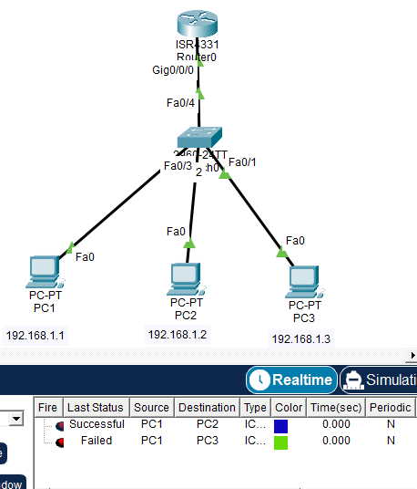

Step 1: Check Device Status
- Opened PC3.
- Verified IP configuration.
- IP address was correctly configured.
- Therefore, the issue was not related to IP settings.
Step 2: Inspect Cable Connection
- Examined the connection between PC3 and Switch0.
- Found that the cable was disconnected.
- Reconnected the cable.
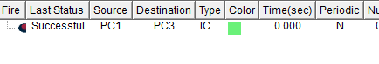
Step 5: Verify Connectivity
After reconnecting the cable:
ping 192.168.1.3
Result:
Reply from 192.168.1.3
Connectivity was restored successfully.

- Create a troubleshooting checklist for diagnosing slow internet issues in a home WiFi network, including at least 8 steps covering both hardware and software checks
Ans.
Step | Check | Purpose
1 | Check all cables and power connections | Ensure the modem and router are properly connected and powered on.
2 | Verify router status lights | Confirm that Internet, WAN, and WiFi indicators are functioning normally.
3 | Restart the modem and router | Temporary issues can often be resolved by rebooting network devices.
4 | Check WiFi signal strength | Weak signals can cause slow speeds, especially when far from the router.
5 | Disconnect unnecessary devices | Too many connected devices can consume bandwidth and slow the network.
6 | Run a speed test | Compare actual internet speed with the speed provided by the ISP.
7 | Perform a ping test | Check network latency and packet loss using commands such as ping 8.8.8.8.
8 | Check device network settings | Verify IP address, DNS settings, and ensure the device is connected to the correct WiFi network.

Detailed Troubleshooting Steps:

Step 1: Check Cables and Connections
- Ensure that Ethernet cables, power cables, and modem connections are securely plugged in and not damaged.

Step 2: Verify Router Status Lights
- Check that the Power, Internet, WAN, and WiFi LEDs are on and showing normal operation.

Step 3: Restart Network Devices
- Turn off the modem and router for about 30 seconds and then power them back on.

Step 4: Check WiFi Signal Strength
- Move closer to the router and see if internet performance improves. Weak signals can reduce speed significantly.

Step 5: Disconnect Unused Devices
- Smart TVs, phones, gaming consoles, and other devices may consume bandwidth even when not actively used.

Step 6: Run a Speed Test
- Use an online speed test to measure download speed, upload speed, and latency.

Step 7: Run a Ping Test
- Example:
- ping 8.8.8.8
- High response times or packet loss may indicate network congestion or connectivity problems.

Step 8: Check Device Settings
- Verify that the device has a valid IP address and correct DNS settings. Reconnect to the WiFi network if necessary.

- You receive a complaint that a user cannot access Instagram and YouTube on their laptop, but WhatsApp Web works fine. Write down the first 5 troubleshooting steps you would perform to identify if the issue is with hardware, software, or network configuration.
Ans. Scenario: A user reports that Instagram and YouTube do not open on their laptop, but WhatsApp Web works normally.

Step 1: Check Internet Connectivity
- Open other websites such as Google or Wikipedia.
- If other websites work, the internet connection is active.
- This helps determine whether the issue is with the network or specific websites.

Step 2: Check Browser Issues
- Try opening Instagram and YouTube in a different browser (Chrome, Edge, Firefox, etc.).
- Clear browser cache and cookies.
- If the sites work in another browser, the issue is likely software-related.

Step 3: Test DNS Resolution
Open Command Prompt and run:
Ping www.youtube.com
ping www.instagram.com
- If the domain names cannot be resolved, there may be a DNS configuration problem.
- Try changing DNS to Google DNS (8.8.8.8 and 8.8.4.4).

Step 4: Check Firewall or Security Software
- Temporarily disable the firewall or antivirus web protection.
- Check if Instagram and YouTube are being blocked by security software or parental controls.
- Re-enable security software after testing.

Step 5: Check Network Restrictions
- Verify whether the WiFi router, company network, or ISP has blocked Instagram or YouTube.
- Try accessing the websites using a mobile hotspot.
- If they work on the hotspot, the issue is likely a network configuration or filtering problem.

